Deploying Cybersecurity Honeypots as a Defensive Monitoring Tool in Small-Scale Network Environments
by
Alexander R. Weber
Project Submitted in Partial Fulfillment of the
Requirements for the Degree of
Bachelor of Science in Computer Security Technology
in the
Department of Security Systems
School of Engineering Technologies

© Alexander Weber 2026
Farmingdale State College
Spring 2026

Copyright in this work is held by the author. Please ensure that any reproduction
or re-use is done in accordance with the relevant national copyright legislation.

Declaration of Committee
Name: | Alexander Robert Weber
Degree: | Bachelor of Science in Computer Security Technology
Title: | Deploying Cybersecurity Honeypots as a Defensive Monitoring Tool in Small-Scale Network Environments
Committee: | Chair: | Dr. M. Nazrul Islam  Department Chair, Computer Security
Dr. Tarik Eltaeib
Supervisor
Course Instructor, Senior Project Writing Intensive, Computer Security

Academic Integrity Policy
Because intellectual honesty is a cornerstone of all academic and scholarly work, each member of the Farmingdale State College campus community is expected to maintain academic integrity. Farmingdale State College has developed regulations concerning academic dishonesty and integrity to protect all students and to maintain an ethical academic environment. For more information, click the updated link for the college-wide Academic Integrity Policy
It is important for you to understand the concept of plagiarism. Plagiarism is intentionally representing the words, images or ideas of another as one’s own in any academic exercise. This includes words, images or ideas in either print or electronic format.

Abstract
Modern cybersecurity threats continue to increase in complexity as attackers develop new methods to exploit vulnerabilities in networked systems. Honeypots have emerged as an important defensive strategy that allows organizations to observe and analyze malicious behavior in a controlled environment. This study explores how honeypots contribute to detection, monitoring, and analysis of threats, particularly within small-scale networks where resources may be limited. The ability to capture attacker behavior in real time provides valuable insights that can strengthen security practices and improve defensive measures. Furthermore, honeypots serve as both research and operational tools, bridging the gap between theoretical cybersecurity concepts and practical implementation. This study includes the deployment of a cloud-based honeypot using Amazon Web Services (AWS) and the T-Pot platform, demonstrating how real-time attack data can be collected and analyzed in a controlled environment. Overall, the integration of honeypots into cybersecurity strategies offers a proactive approach to understanding and mitigating threats. The results of this study demonstrate that even small-scale honeypot deployments can successfully capture realistic attack behavior and provide actionable cybersecurity insights.
Keywords: honeypots; cybersecurity; AWS; network security; intrusion detection

Table of Contents

Declaration of Committee ii
Academic Integrity Policy iii
Abstract iv
Table of Contents v
List of Figures vi
Chapter 1. Introduction 1
Chapter 2. Literature Review 2
Chapter 3. Methodology 6
Chapter 4. Deployment Design 13
Chapter 5. Data Collection 14
Chapter 6. Analysis 18
Chapter 7. Discussion 21
Chapter 8. Limitations 27
Chapter 9. Future Research 28
Chapter 10. Conclusion 29
References 31

List of Figures
Figure 1 12
Figure 2 13
Figure 3 16
Figure 4 17
Figure 5 19
Figure 6 20
Figure 7 26

Introduction
Cybersecurity continues to evolve as attackers develop increasingly sophisticated methods to exploit vulnerabilities in modern networks. Traditional security tools such as firewalls and intrusion detection systems are often insufficient for fully understanding attacker behavior. Honeypots provide a unique approach by intentionally attracting attackers and capturing their interactions in a controlled environment.

This study examines the role of honeypots as a defensive monitoring tool in small-scale network environments. The research focuses on how honeypots can be used to detect, monitor, and analyze cyber threats, while also providing insight into attacker behavior. Additionally, this study includes the deployment of a real-world honeypot system using Amazon Web Services (AWS) and the T-Pot platform.

The purpose of this research is to evaluate the effectiveness of honeypots in capturing attack data and identifying patterns in malicious activity. By combining theoretical research with practical implementation, this study contributes to a deeper understanding of how honeypots can enhance cybersecurity strategies.

Literature Review
As cyber threats become more sophisticated, attackers are continuously developing new methods to exploit vulnerabilities in modern networks. As a result, traditional security tools such as firewalls and intrusion detection systems are often not enough on their own to fully understand or anticipate threats. Honeypots have emerged as an important defensive strategy that allows organizations to observe and analyze malicious behavior in a controlled environment. Unlike conventional security mechanisms that focus primarily on blocking attacks, honeypots are designed to attract attackers, providing a unique opportunity to study their behavior, techniques, and intentions in real time (Alata et al., 2006).

This study explores how honeypots contribute to the detection, monitoring, and analysis of threats, particularly within small-scale networks where resources may be limited. In these environments, organizations often lack access to advanced and expensive security infrastructure, making cost-effective solutions like honeypots especially valuable. The ability to capture attacker behavior in real time provides insights into how cyber threats operate, which can strengthen security practices and improve defensive measures (Alata et al., 2006). Additionally, honeypots can act as an early warning system by detecting suspicious activity before it reaches critical systems, allowing administrators to respond proactively rather than reactively.

Furthermore, honeypots serve as both research and operational tools, bridging the gap between theoretical cybersecurity concepts and practical implementation. Research conducted by Pouget and Dacier (2011) highlights how honeypots can be used in digital forensics to reconstruct attack scenarios and better understand how intrusions occur. By analyzing the data collected from honeypots, security professionals can identify common attack vectors and develop more effective mitigation strategies. This reinforces the idea that honeypots are not only useful for observing threats but also for improving overall cybersecurity frameworks.

Their effectiveness lies in their ability to generate high-quality data, as any interaction with the system is likely malicious. This characteristic significantly reduces the amount of noise typically associated with network monitoring tools, allowing for more focused and efficient analysis. According to Sobesto (2015), attackers often follow predictable patterns, such as automated scanning, brute-force login attempts, and exploitation of known vulnerabilities. Honeypots are particularly effective at capturing these behaviors, making them valuable for identifying trends and understanding attacker methodologies over time.

In addition, research by Seifert et al. (2009) demonstrates how analyzing malicious behavior can complement detection systems, particularly when combined with heuristic and analytical techniques. This suggests that honeypots should not be used in isolation but rather as part of a broader cybersecurity strategy. When integrated with other tools, such as intrusion detection systems and threat intelligence platforms, honeypots can enhance an organization’s ability to detect and respond to threats more effectively.

More recent studies have expanded the application of honeypots beyond traditional networks. For example, Franco et al. (2021) examined the use of honeypots in Internet of Things (IoT) and cyber-physical systems, highlighting their adaptability across different technological environments. As the number of connected devices continues to grow, the attack surface also expands, making it increasingly important to monitor and analyze potential threats in these systems. Honeypots provide a flexible solution that can be tailored to different network types and security needs (Franco et al., 2021).

Despite their advantages, honeypots also present certain limitations that must be considered. Advanced attackers may be able to detect honeypots and avoid interacting with them, which can reduce their effectiveness. Additionally, improper configuration of a honeypot can introduce security risks if it is exploited as a point of entry into a network. Krawetz (2004) discusses anti-honeypot technologies that attackers may use to identify deceptive systems, emphasizing the need for careful design and implementation. These challenges highlight the importance of maintaining realistic configurations and continuously updating honeypot systems to remain effective.

Overall, the literature demonstrates that honeypots are powerful tools for collecting attack data, analyzing malicious behavior, and supporting cybersecurity research. They provide valuable insights into attacker strategies and contribute to the development of more effective defensive measures. However, there remains a gap in research regarding their effectiveness in smaller, controlled environments, particularly in practical deployments. This study aims to address that gap by evaluating how honeypots perform as a defensive monitoring tool within a controlled network setting, ultimately contributing to a better understanding of their role in modern cybersecurity.

Methodology
The evolving landscape of cybersecurity requires adaptive research methods to better understand how attackers exploit vulnerabilities in modern networks. As a result, security research must also adapt by implementing tools that not only detect threats but also analyze attacker behavior in depth. Honeypots have emerged as an important defensive strategy that allows organizations to observe and analyze malicious behavior in a controlled environment. Unlike traditional security systems that focus on blocking or preventing attacks, honeypots are intentionally designed to attract attackers, creating opportunities to study real-world threats without placing critical systems at risk. This study explores how honeypots contribute to the detection, monitoring, and analysis of threats, particularly within small-scale networks where resources may be limited (Pouget & Dacier, 2011).

The research design for this study is based on the deployment of a controlled honeypot environment that simulates vulnerable network services. The honeypot was configured to mimic commonly targeted systems, such as open ports, outdated software versions, and weak authentication mechanisms, in order to increase the likelihood of attracting malicious activity. This controlled setup ensures that all interactions can be safely monitored while maintaining a realistic environment that encourages attacker engagement. By carefully designing the honeypot to resemble a legitimate system, the study aims to capture authentic attack behavior rather than artificially induced interactions (Pouget & Dacier, 2011).

The deployment took place within a virtualized cloud environment to ensure that any malicious activity remained contained and did not impact external systems. This approach allows for flexibility in configuring and modifying the honeypot while maintaining a high level of security. Network traffic was continuously monitored using logging tools that captured detailed information about each interaction, including IP addresses, timestamps, attempted commands, and types of attacks. These logs served as the primary data source for analysis, providing insight into how attackers interacted with the honeypot over time.

Data collection focused on several key types of malicious activity. These included port scanning attempts, which are often used by attackers to identify open services; brute-force login attempts, in which attackers try multiple credential combinations to gain access; and exploitation techniques targeting known vulnerabilities in software or system configurations. By categorizing these activities, the study was able to identify common patterns and trends in attacker behavior. Additionally, the frequency and timing of attacks were analyzed to determine whether certain types of activity occurred more often during specific periods or under particular conditions.

To ensure the reliability and validity of the findings, the honeypot remained active over an extended period of time, allowing for the collection of a sufficient amount of data. This longitudinal approach helped capture a wider range of attack types and reduced the likelihood of bias caused by short-term observations. The collected data was then analyzed qualitatively to identify recurring behaviors and strategies used by attackers. This included examining how attackers attempted to gain access, what commands they executed once inside the system, and whether they attempted to escalate privileges or move laterally within the network.

Furthermore, this study incorporated elements of digital forensics by analyzing recorded interactions to reconstruct attack scenarios. According to Pouget and Dacier (2011), honeypots can provide detailed forensic evidence that helps researchers understand the sequence of actions taken during an attack. By examining these sequences, the study identified common attack pathways and highlighted potential vulnerabilities that may exist in real-world systems. This forensic perspective added an additional layer of depth to the analysis, allowing for a more comprehensive understanding of attacker behavior.

Ethical considerations were also an important component of this methodology. The honeypot was configured to ensure that it did not unintentionally harm other systems or participate in malicious activities. For example, outbound traffic was restricted to prevent the honeypot from being used as a launch point for further attacks. Additionally, no attempt was made to actively engage with or retaliate against attackers, as the focus of the study was purely observational. This ensured that the research remained aligned with ethical cybersecurity practices and avoided legal or operational risks.

Despite its strengths, this methodology also has limitations. One limitation is that more advanced attackers may recognize the honeypot and avoid interacting with it, which could reduce the amount of useful data collected. Additionally, the controlled nature of the environment may not fully replicate the complexity of real-world networks, potentially limiting the generalizability of the findings. However, by carefully designing the honeypot and maintaining realistic configurations, these limitations can be minimized.

To support the research objectives, a practical honeypot system was deployed using Amazon Web Services (AWS). The honeypot environment was implemented using the T-Pot platform, an open-source, multi-honeypot solution that integrates several honeypot technologies into a single deployment (Deutsche Telekom Security, 2024). T-Pot provides a comprehensive framework for capturing and analyzing malicious activity across multiple network services, making it well-suited for small-scale cybersecurity research environments. The honeypot was hosted on an Elastic Compute Cloud (EC2) instance configured with a public IP address to allow external access from the internet. A moderately sized virtual machine (m7i-flex.large) running Ubuntu Linux was used to simulate a realistic server environment.

The initial deployment of the honeypot encountered several technical challenges that required troubleshooting and system reconfiguration. Although the containers were successfully created using Docker Compose, the honeypot services were not externally accessible during initial testing. Initial network scans performed from a Kali Linux machine showed all ports in a closed state, indicating that the services were not properly exposed to the internet. Further investigation revealed that the issue was related to the systemd service configuration, which repeatedly stopped and restarted the containers, preventing them from remaining active long enough to accept connections.

In addition to the service configuration issue, a port conflict was identified on TCP port 25. The default mail service (Exim4) running on the Ubuntu host was already bound to this port, preventing the Mailoney honeypot container from starting. This caused the entire T-Pot deployment to fail during initialization. To resolve this issue, the Exim4 service was disabled and stopped, freeing port 25 for use by the honeypot environment.

The systemd service was then reconfigured to use a one-shot execution model with detached container startup (docker compose up -d). This change ensured that the containers would remain running independently rather than being tied to a continuously restarting service process. After applying these fixes, all honeypot containers successfully initialized and remained active, allowing external connections to be established.

The system was intentionally configured with exposed services to attract malicious activity. Specifically, port 22 (SSH) was opened, and weak authentication credentials were enabled to simulate a vulnerable system. Security group rules were configured to allow inbound traffic from any source (0.0.0.0/0), ensuring that the honeypot was visible to automated scanners and potential attackers.

A low-interaction SSH honeypot (such as Cowrie) was deployed to capture login attempts, commands executed by attackers, and session activity. All interactions with the system were logged and stored for later analysis. This configuration allowed for the safe observation of attacker behavior without exposing any real systems or sensitive data.

The deployment was isolated within the AWS environment to prevent lateral movement or unintended impact on other systems. Outbound traffic restrictions were applied to ensure that the honeypot could not be used as a platform for launching further attacks. This approach ensured that the research remained ethical while still capturing realistic attack behavior. The deployment configuration of the EC2 instance and security settings can be seen in Figure 1.

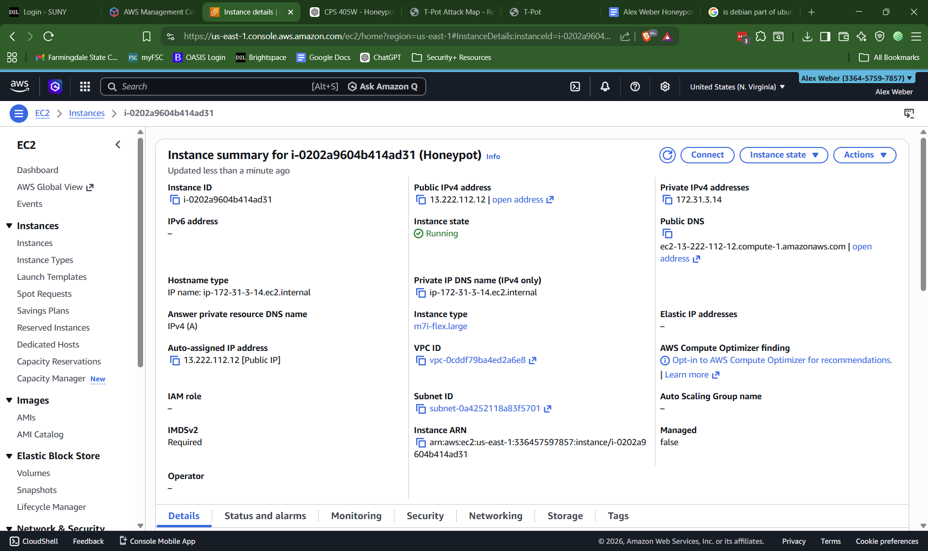
Figure 1
AWS EC2 honeypot deployment configuration.

Deployment Design
The honeypot architecture was designed to simulate a realistic yet controlled network environment within a cloud infrastructure. As shown in Figure 2, the system consists of an internet-facing EC2 instance configured with intentionally exposed services to attract malicious traffic. The honeypot operates within a secure cloud environment, ensuring that all interactions are contained and monitored. Logging mechanisms were integrated to capture all incoming connections, authentication attempts, and commands executed by attackers. This architecture allows for safe observation of cyber threats while maintaining isolation from production systems.


Figure 2
AWS honeypot network architecture showing exposed services and logging components.

Data Collection
The increasing frequency and complexity of cyberattacks highlight the need for tools that can effectively capture and analyze malicious behavior. Honeypots have emerged as an important defensive strategy that allows organizations to observe and analyze malicious behavior in a controlled environment. This study explores how honeypots contribute to detection, monitoring, and analysis of threats, particularly within small-scale networks where resources may be limited. The ability to capture attacker behavior in real time provides valuable insights that can strengthen security practices and improve defensive measures (Seifert et al., 2009). Furthermore, honeypots serve as both research and operational tools, bridging the gap between theoretical cybersecurity concepts and practical implementation. Their effectiveness lies in their ability to generate high-quality data, as any interaction with the system is likely malicious. This characteristic makes honeypots especially useful for identifying patterns in attacker behavior, such as scanning, exploitation attempts, and unauthorized access. Overall, the integration of honeypots into cybersecurity strategies offers a proactive approach to understanding and mitigating threats (Seifert et al., 2009).

Data collection was performed using multiple honeypot services within the T-Pot platform, each designed to capture specific types of malicious activity. Cowrie was used to log SSH and Telnet interactions, including login attempts, credentials used, and commands executed during attacker sessions. Dionaea captured network scanning behavior and potential exploitation attempts across services such as SMB, FTP, and database ports. Heralding recorded authentication attempts across multiple protocols, including SMTP, IMAP, POP3, and HTTP.

During testing, network scans conducted using Nmap revealed multiple open ports, including 21 (FTP), 22 (SSH), 23 (Telnet), 25 (SMTP), 80 (HTTP), 443 (HTTPS), and 3306 (MySQL). These open ports simulated a vulnerable system and attracted interaction attempts. Brute-force login simulations generated repeated authentication attempts, which were successfully recorded in Cowrie logs. Web probing and enumeration attempts triggered responses from web-based honeypots, such as Wordpot and h0neytr4p.
The collected logs included timestamps, source IP addresses, attempted credentials, commands executed, and protocol-specific interactions. These logs provided a detailed dataset for analyzing attacker behavior and identifying recurring attack patterns. The geographic distribution and volume of incoming attacks were visualized using the T-Pot Attack Map interface, as shown in Figure 3.
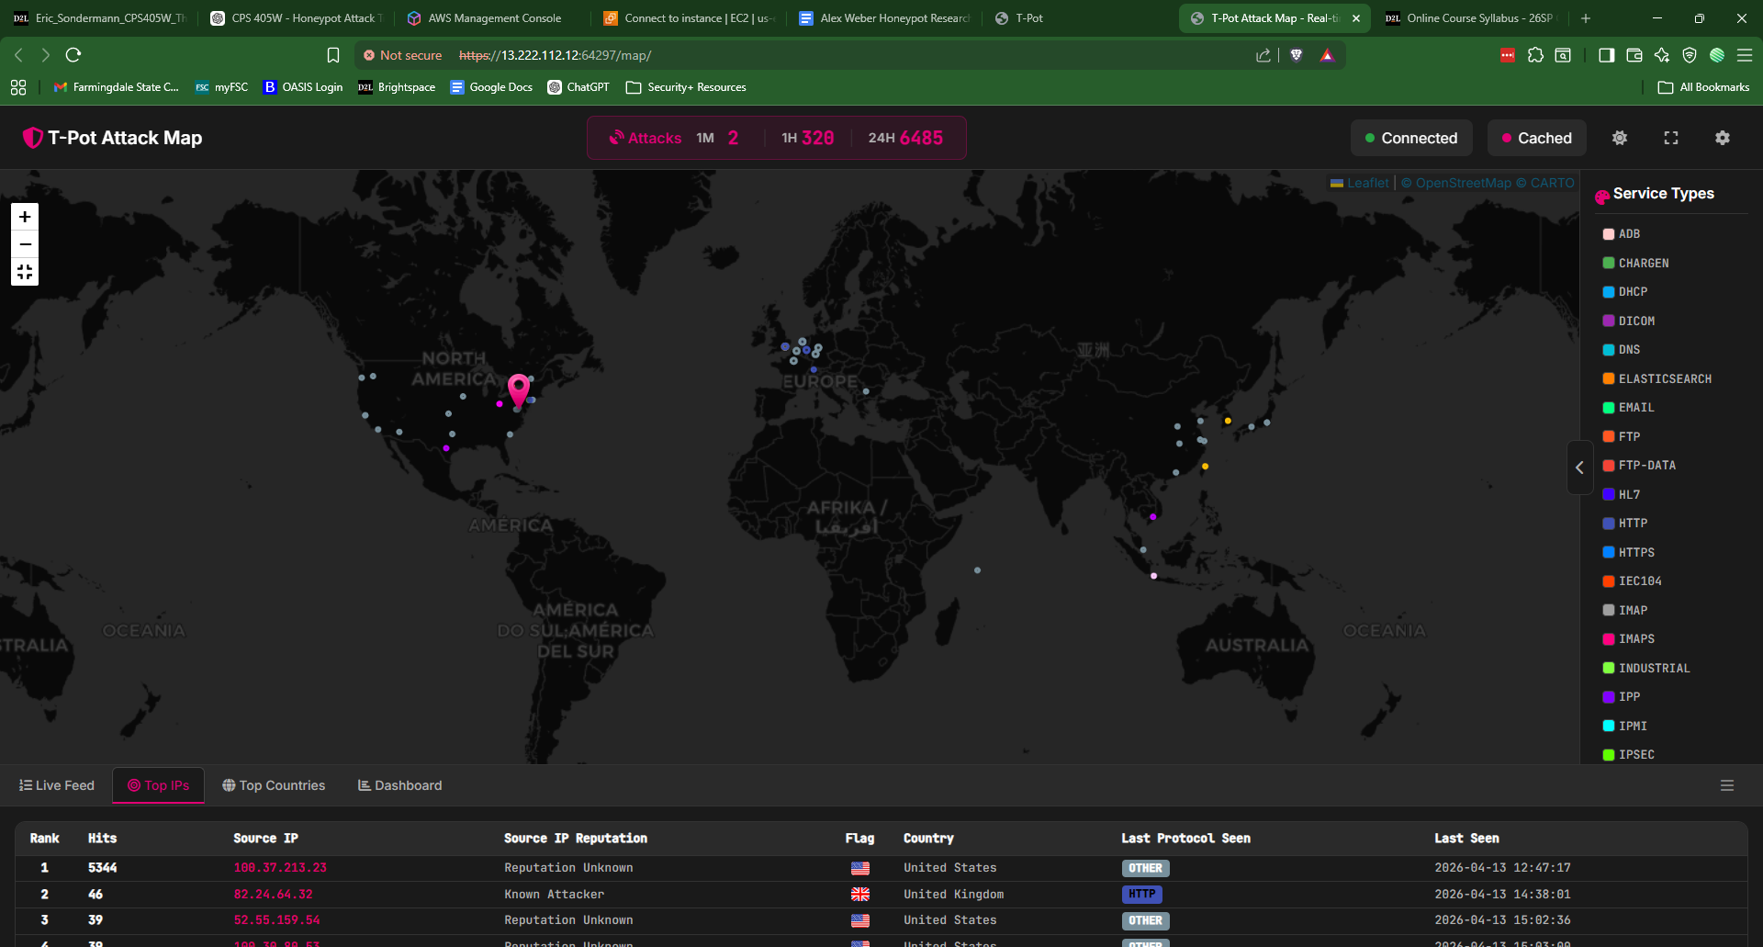
Figure 3
T-Pot Attack Map displaying real-time global attack sources interacting with the deployed honeypot.

To validate the functionality of the deployed honeypot, controlled attack simulations were conducted from an external Kali Linux system. These simulations were designed to replicate common attacker behaviors observed in real-world environments. Network reconnaissance was performed using Nmap to identify open ports and services exposed by the honeypot. Following this, credential brute-force attempts were simulated using Hydra against the SSH service, while web-based enumeration and probing were conducted using tools such as cURL and Gobuster. The results of this scan are shown in Figure 4.

Additional interaction with exposed services was performed manually using Telnet, FTP, and Netcat to simulate unauthorized access attempts across multiple protocols. These actions triggered logging mechanisms within various honeypot services, including Cowrie (SSH/Telnet), Dionaea (malware and vulnerability scanning), and Heralding (multi-protocol authentication services). The purpose of these simulations was not to exploit the system, but to generate realistic interaction data for analysis. All activity was conducted in a controlled and ethical manner, targeting only the researcher’s own cloud-based environment.

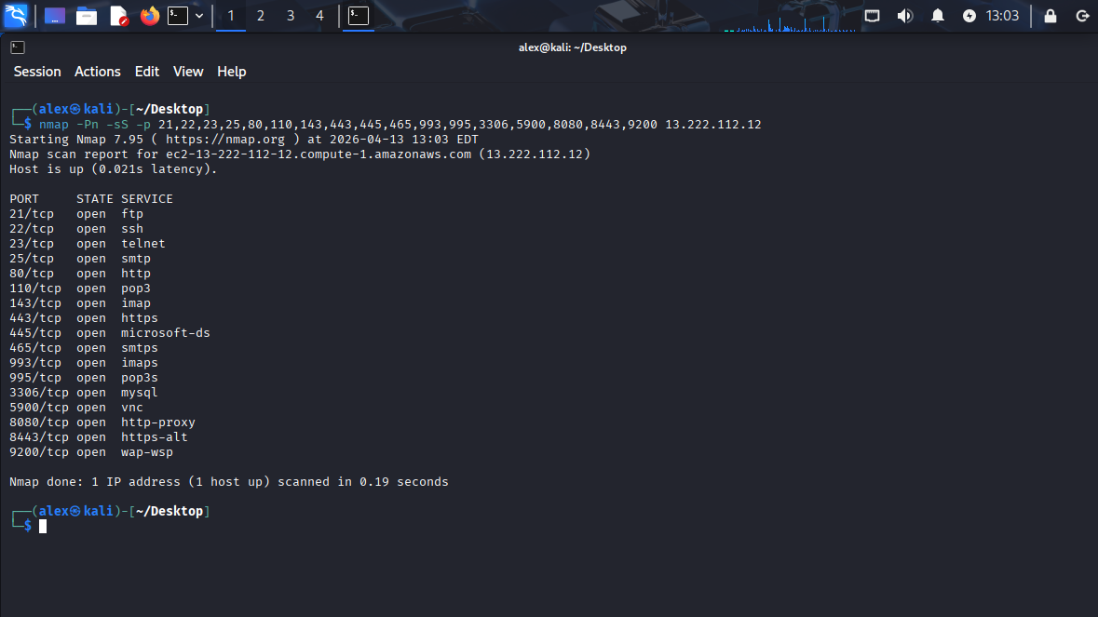
Figure 4
Nmap scan results confirming multiple externally accessible services exposed by the honeypot environment.

Analysis
The analysis of collected data revealed clear patterns consistent with automated attack behavior. Simulated brute-force attacks generated multiple rapid login attempts using commonly used usernames and passwords, demonstrating how attackers rely on credential lists to gain unauthorized access. Network scans identified exposed services and confirmed that attackers typically begin with reconnaissance before attempting exploitation.

Interaction logs from Cowrie showed that once a connection was established, attackers attempted to execute basic system commands, such as directory listing and system identification commands. This behavior aligns with known attacker workflows, where initial access is followed by reconnaissance of the compromised system. Similarly, Heralding logs demonstrated repeated authentication attempts across multiple services, indicating that attackers often target multiple protocols simultaneously. An example of these attacker interactions is shown in Figure 5.

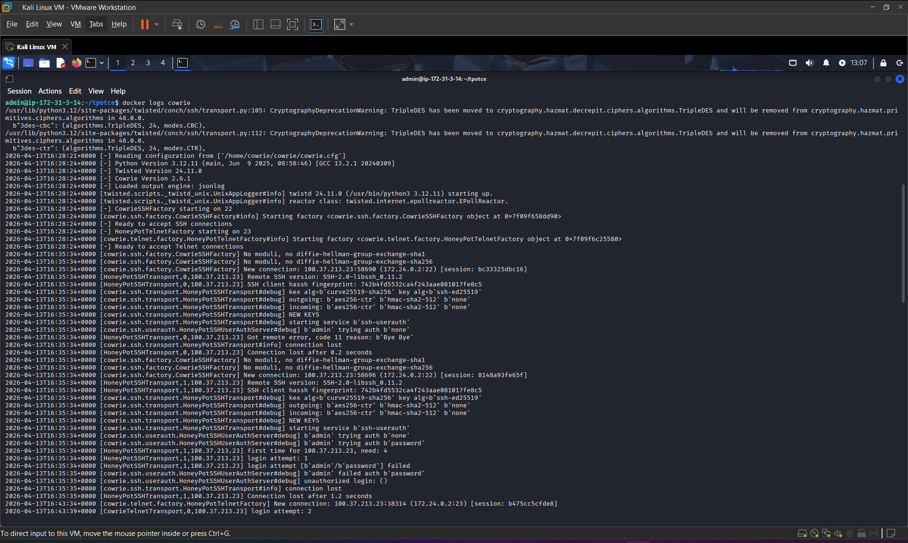
Figure 5
Example of Cowrie logs capturing SSH authentication attempts and attacker command execution.

Additionally, scanning activity captured by Dionaea reflected typical vulnerability probing behavior, where attackers scan for known services and attempt to identify potential weaknesses. These findings support existing research that suggests attackers rely heavily on automation and predictable patterns when targeting exposed systems.

As shown in Figure 6, attack traffic originated from multiple global regions, with the United States generating the highest number of hits, followed by the United Kingdom and Switzerland. The data also indicates that HTTP was the most frequently targeted protocol, suggesting a high volume of automated web-based scanning and probing activity. Additionally, the presence of protocols such as SMB and Telnet demonstrates that attackers were attempting to exploit a variety of services exposed by the honeypot. The diversity of source IP addresses further supports the conclusion that the observed traffic was largely automated and distributed across global networks. These findings highlight the global and opportunistic nature of cyberattacks, where exposed systems are quickly discovered and targeted regardless of geographic location.

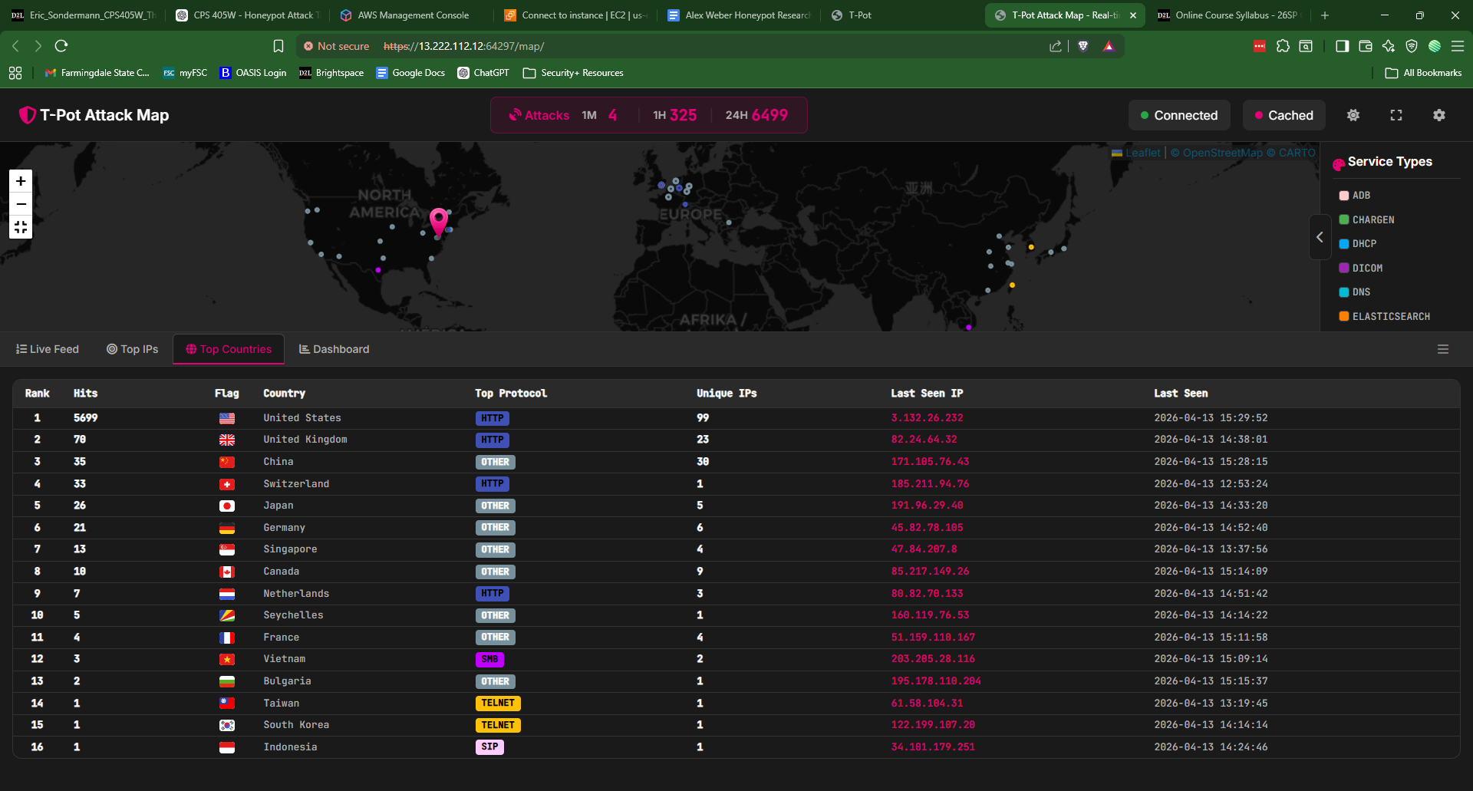
Figure 6
T-Pot Attack Map “Top Countries” view illustrating attack frequency, geographic distribution, protocols, and unique IP activity.

Discussion
As cyber threats continue to advance, organizations must adopt proactive and adaptive security strategies to effectively defend against modern attacks. Honeypots have emerged as an important defensive tool that allows organizations to observe and analyze malicious behavior in a controlled environment, rather than simply reacting to attacks after they occur. This study explored how honeypots contribute to the detection, monitoring, and analysis of threats, particularly within small-scale networks where resources may be limited. The findings reinforce the idea that honeypots provide a unique advantage by capturing attacker behavior in real time, offering valuable insights that can strengthen security practices and improve defensive measures (Alata et al., 2006).

One of the most significant findings from this study is the ability of honeypots to generate high-quality, focused data. Unlike traditional security systems that must filter through large volumes of legitimate and malicious traffic, honeypots primarily attract malicious interactions. This results in a cleaner dataset that allows for more efficient analysis. The data collected through the honeypot deployment revealed consistent patterns of behavior, such as automated scanning, repeated login attempts, and attempts to exploit known vulnerabilities. These findings align with previous research, which suggests that attackers frequently rely on automated tools to identify and exploit weak points in a network (Sobesto, 2015). By capturing these behaviors, honeypots provide actionable intelligence that can be used to improve network defenses.

Additionally, the results highlight the role of honeypots as an early detection mechanism. In many cases, attackers interact with honeypots before attempting to target legitimate systems, making honeypots an effective first line of observation. This allows administrators to identify potential threats before they escalate into more serious security incidents. The ability to detect suspicious activity at an early stage is particularly valuable in small-scale environments, where organizations may lack advanced monitoring tools or dedicated security teams. As a result, honeypots offer a cost-effective solution for enhancing visibility into network activity without requiring significant investment in infrastructure.

Another important aspect of this study is the insight gained into attacker behavior and strategies. The analysis of collected data revealed that attackers often follow predictable sequences, such as scanning for open ports, attempting to access services, and executing commands once access is gained. These patterns are consistent with findings from Alata et al. (2006), who demonstrated that honeypots are effective in capturing real-world attack data and identifying common attack methodologies. Understanding these patterns is critical for developing stronger defensive measures, as it allows organizations to anticipate potential threats and implement targeted security controls.

Furthermore, this study emphasizes the value of honeypots as both research and operational tools. From a research perspective, honeypots provide a controlled environment for studying cyber threats without risking production systems. From an operational standpoint, they serve as a practical tool for monitoring network activity and identifying vulnerabilities. This dual role highlights the versatility of honeypots and their importance in modern cybersecurity strategies. By bridging the gap between theoretical knowledge and real-world application, honeypots enable organizations to translate research findings into actionable security improvements.

However, the discussion would be incomplete without addressing the limitations observed during the study. One limitation is the possibility that more sophisticated attackers may detect the presence of a honeypot and avoid interacting with it. This can reduce the amount of useful data collected and limit the effectiveness of the system. Additionally, the controlled environment used in this study may not fully replicate the complexity of real-world networks, which could impact the generalizability of the findings. Despite these limitations, the study still demonstrates the significant value of honeypots in capturing and analyzing malicious activity.

Another challenge is ensuring that honeypots are properly configured and maintained. If a honeypot is not realistic enough, it may fail to attract attackers. On the other hand, if it is not properly secured, it could potentially be exploited and used as a platform for further attacks. This highlights the importance of careful design and continuous monitoring when deploying honeypots. Organizations must strike a balance between realism and security to maximize the effectiveness of the system.

Despite these challenges, the overall findings of this study support the integration of honeypots into broader cybersecurity strategies. When used in combination with other security tools, such as intrusion detection systems and firewalls, honeypots can significantly enhance an organization’s ability to detect and respond to threats. They provide a proactive approach to cybersecurity by focusing on understanding attacker behavior rather than simply blocking attacks.

In conclusion, the discussion highlights the critical role of honeypots in modern cybersecurity. Their ability to generate high-quality data, provide early threat detection, and offer insights into attacker behavior makes them a valuable tool for organizations of all sizes. While there are limitations and challenges associated with their deployment, the benefits of honeypots far outweigh these drawbacks. The integration of honeypots into cybersecurity strategies represents an effective and practical approach to improving network security and staying ahead of evolving threats (Alata et al., 2006).

A key finding from the practical deployment was the importance of proper system configuration in ensuring honeypot effectiveness. Initial deployment failures demonstrated how misconfigured services and port conflicts can prevent honeypots from functioning correctly. Specifically, the conflict on port 25 and the improper systemd configuration highlighted the need for careful system management when deploying containerized security tools. Once these issues were resolved, the honeypot environment successfully attracted and recorded simulated attack traffic, reinforcing the importance of correct deployment practices in cybersecurity research. These findings demonstrate that even a small-scale honeypot deployment can produce meaningful and realistic cybersecurity data, reinforcing its value as both an educational and defensive tool. The active honeypot services running during data collection are shown in Figure 7.
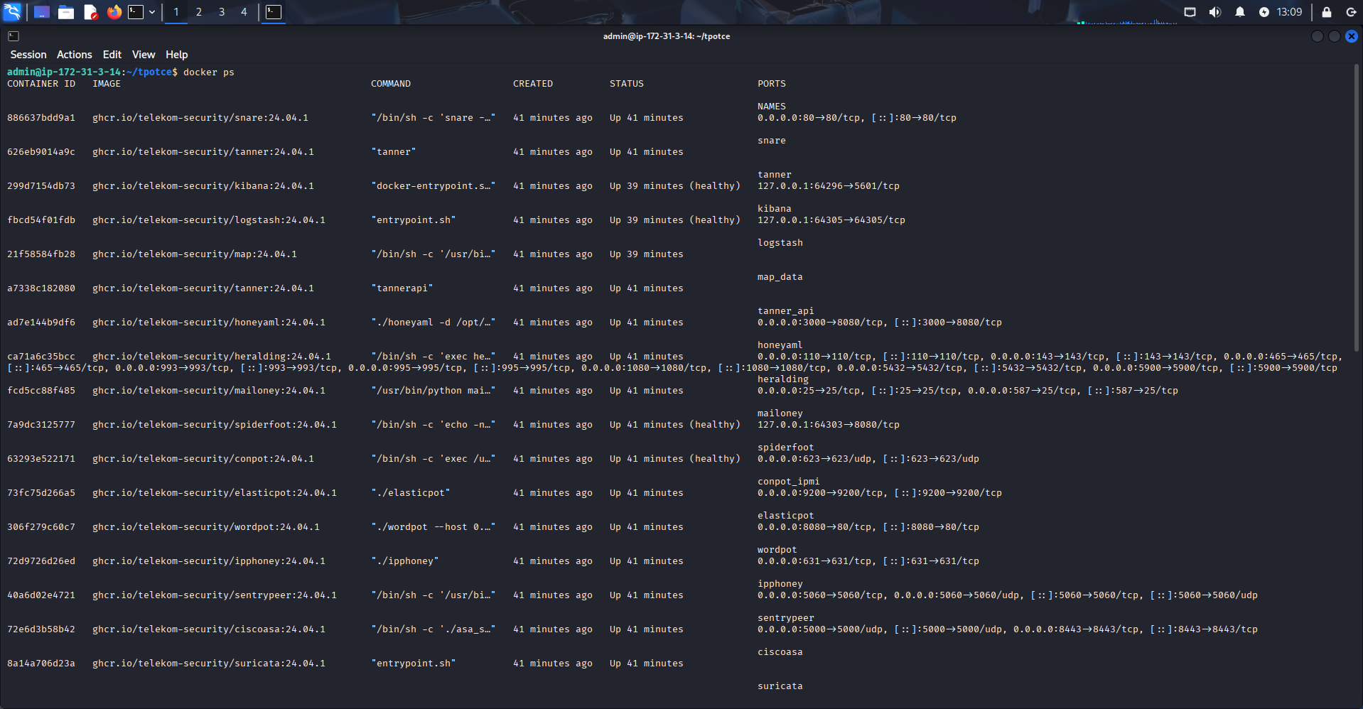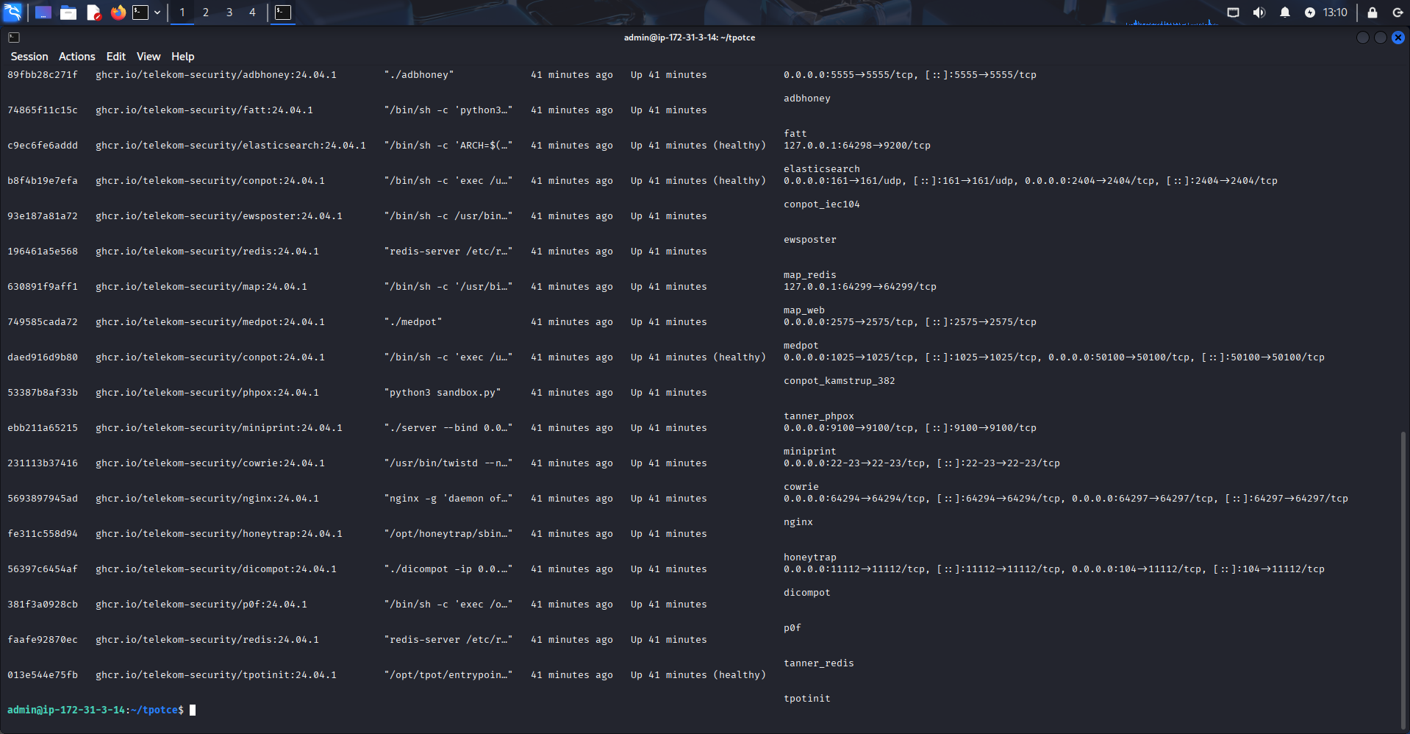
Figure 7
Active honeypot services running within the T-Pot deployment environment.

Limitations
While honeypots provide valuable insights into attacker behavior, several limitations must be considered. One key limitation is that advanced attackers may detect the presence of a honeypot and avoid interacting with it, reducing the effectiveness of data collection. Additionally, the controlled environment used in this study does not fully replicate the complexity of real-world networks, which may limit the generalizability of the findings. Despite these limitations, the honeypot environment still captured meaningful attack patterns that align with real-world behavior.

Future Research
Future research can expand on this study by deploying honeypots in more complex and diverse network environments. This includes integrating honeypots with real production systems, exploring high-interaction honeypots, and analyzing long-term attack trends. Additionally, future work could incorporate automated threat intelligence tools and machine learning techniques to enhance the analysis of collected data. Expanding the scope of deployment would provide deeper insights into attacker behavior across different environments.

Conclusion
This study demonstrates that honeypots are an effective, practical, and scalable solution for monitoring and analyzing malicious activity in small-scale network environments.

The findings of this research highlight how attackers rely heavily on automated techniques such as port scanning, brute-force login attempts, and exploitation of exposed services. By capturing these interactions, the honeypot provided valuable insight into common attack patterns and methodologies. This reinforces the role of honeypots as both a research tool and a defensive mechanism that enhances visibility into network threats.

Additionally, the practical challenges encountered during deployment, including service misconfiguration and port conflicts, emphasize the importance of proper system setup in cybersecurity environments. Overcoming these challenges contributed to a more reliable and effective honeypot implementation.

Overall, the integration of honeypots into cybersecurity strategies offers a proactive approach to understanding and mitigating threats. Even in small-scale deployments, honeypots can provide meaningful data that supports stronger security practices and improved threat awareness.

References
Alata, E., Dacier, M., Deswarte, Y., Kaaniche, M., Kortchinsky, K., Nicomette, V., Pham, V. H., & Pouget, F. (2006). Collection and analysis of attack data based on honeypots deployed on the internet. Springer.
Deutsche Telekom Security. (2024). T-Pot: The all-in-one honeypot platform. GitHub. https://github.com/telekom-security/tpotce
Franco, J., Aris, A., Canberk, B., & Uluagac, A. S. (2021). A survey of honeypots and honeynets for IoT and cyber-physical systems. IEEE Xplore.
Pouget, F., & Dacier, M. (2011). Honeypot-based forensics. ResearchGate.
Seifert, C., Komisarczuk, P., & Welch, I. (2009). Identification of malicious web pages with static heuristics. ResearchGate.
Sobesto, B. (2015). Empirical studies based on honeypots for characterizing attacker behavior. DRUM.
Spitzner, L. (n.d.). Honeypots: Catching the insider threat. IEEE Xplore.

